Open : https://securevpn.airretailer.com

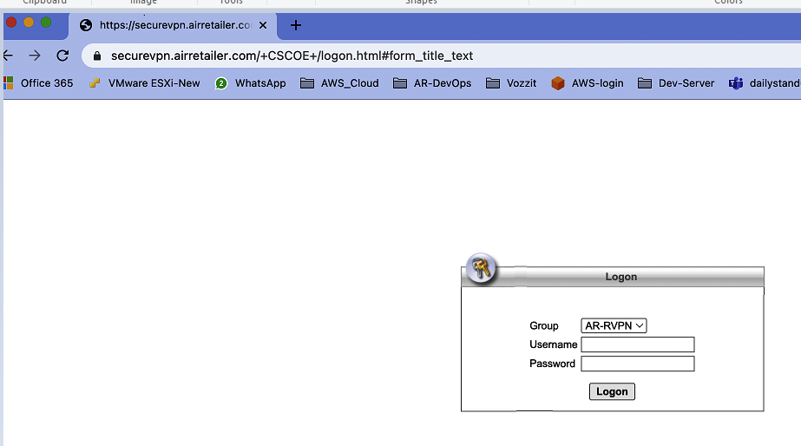
Username:- (firstname) + ( firstletter of second Name) à example Ranganathan Shanmugam
User Name will be: jithin-vz
Password:- Dubai@2025
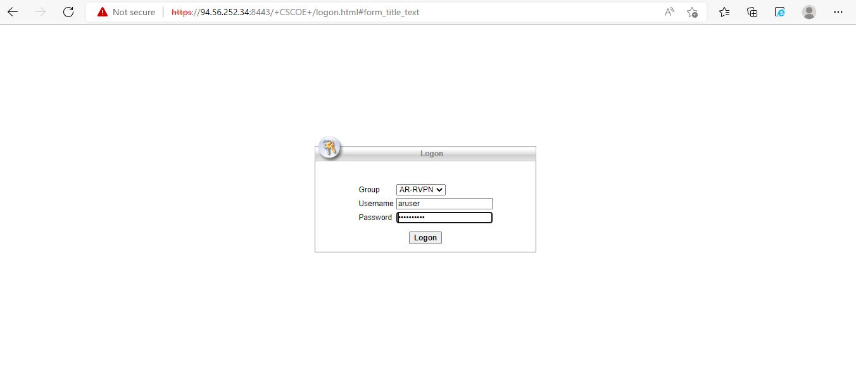
After login download and install software
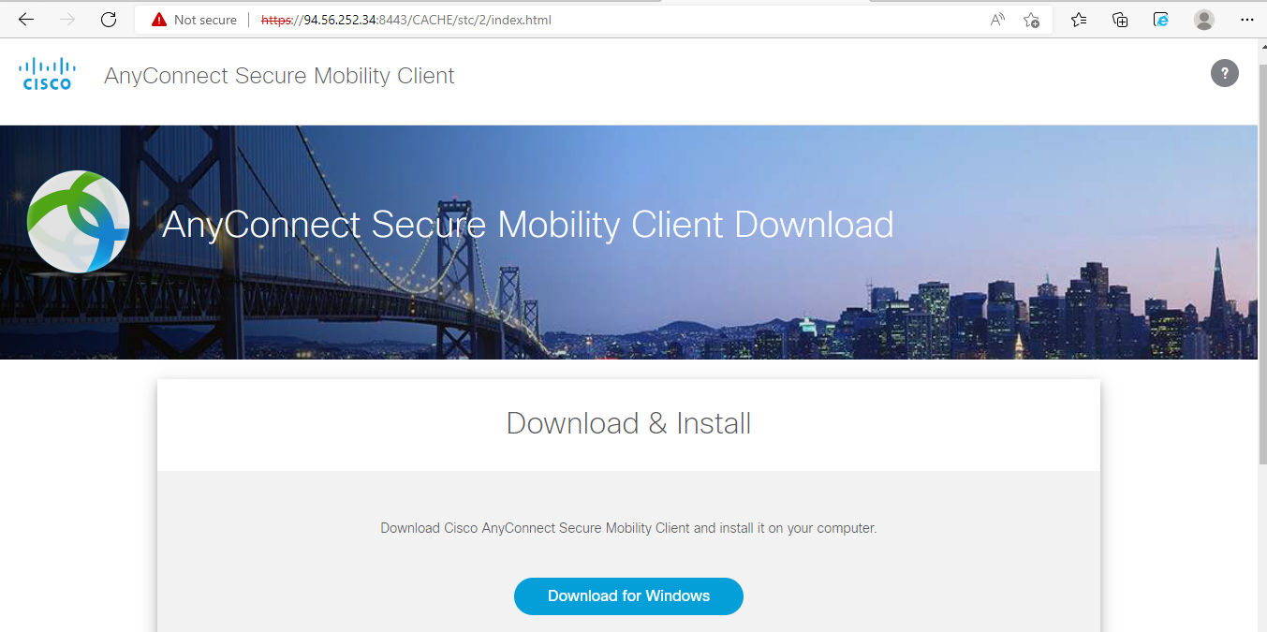

Open cisco AnyConnect secure mobility client

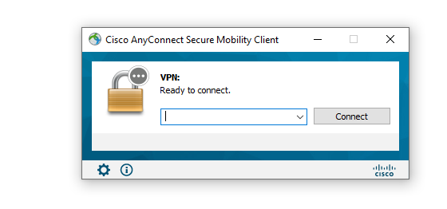
Then open settings
Then setup as below
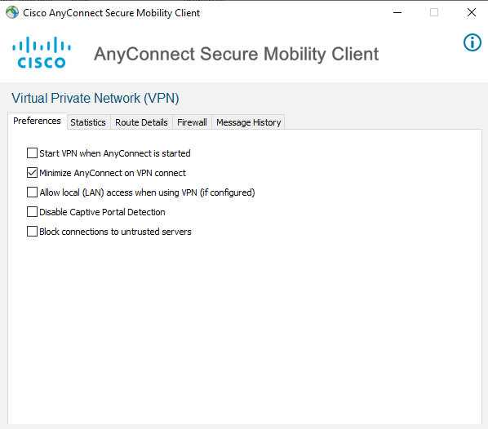

Configure remote server URl : securevpn.airretailer.com

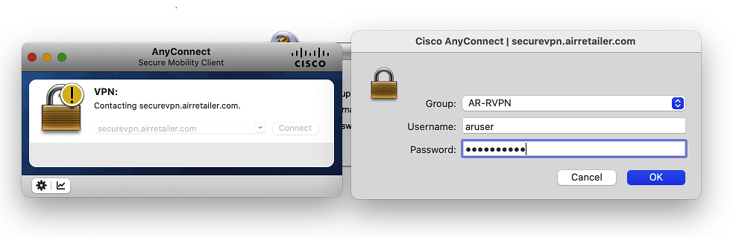
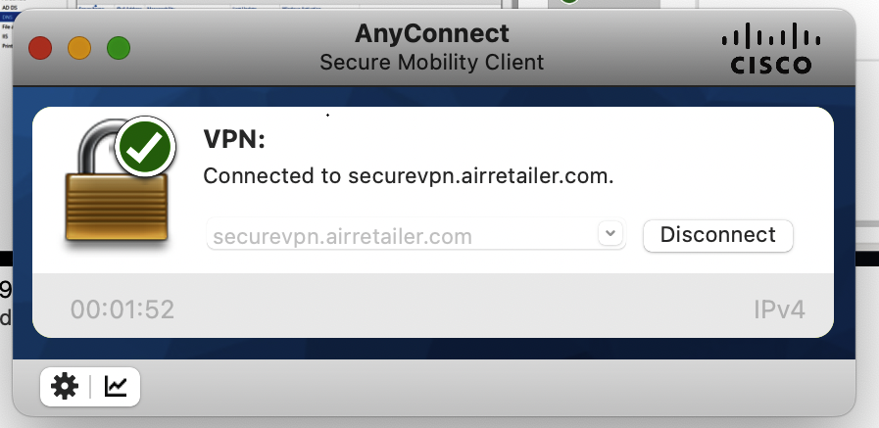
Click connect

Click connect anyway

Find your PC local IP address :

Right click network Icon and select open network and internet settings
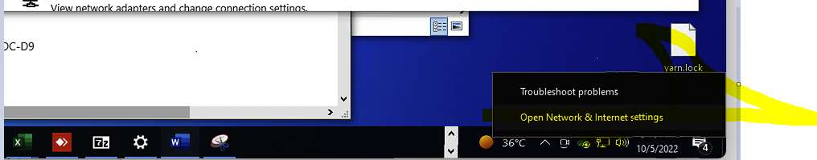
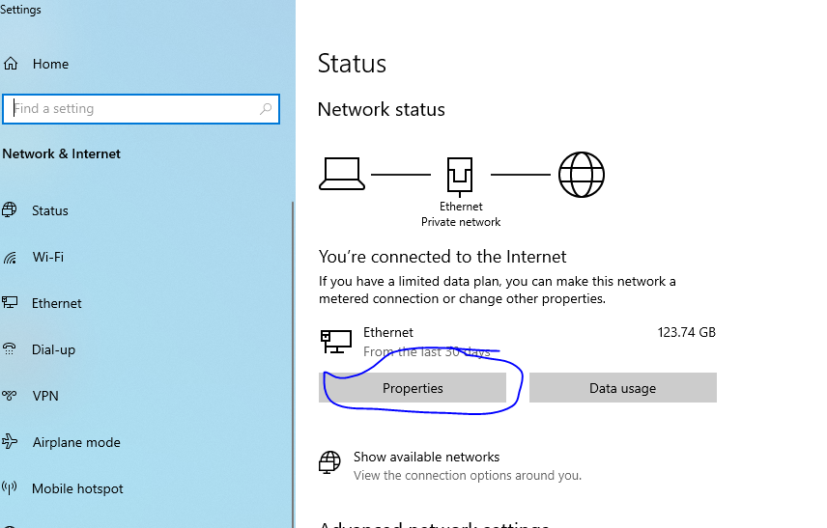

Collect the IP address from local PC
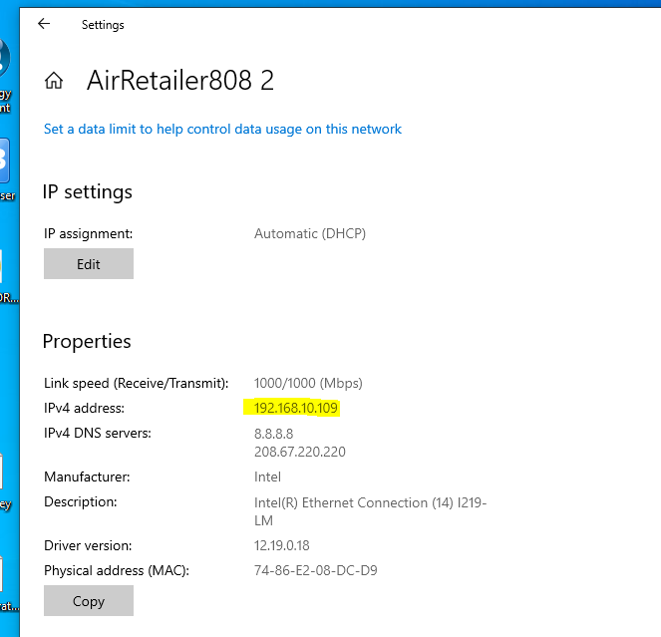

From your personal laptop open Microsoft remote desktop software .
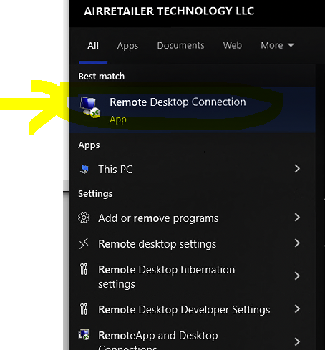

Enter the IP address of your remote PC
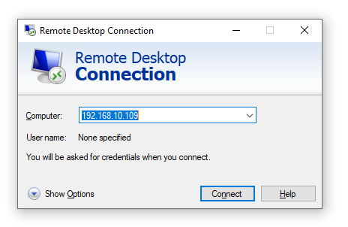

Enter you’re your name and password for remote local PC ;
To find your local user name of PC in your system .
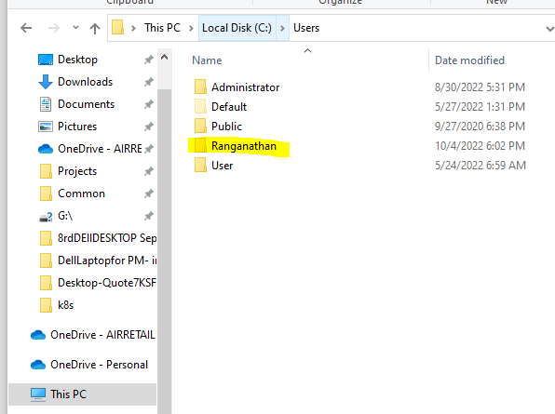

For Windows systems:
Username: airretailer.local\Username
EX: airretailer.local\Ranganathans
Password: Your system password

For Mac systems:
Download : Microsoft remote desktop applications
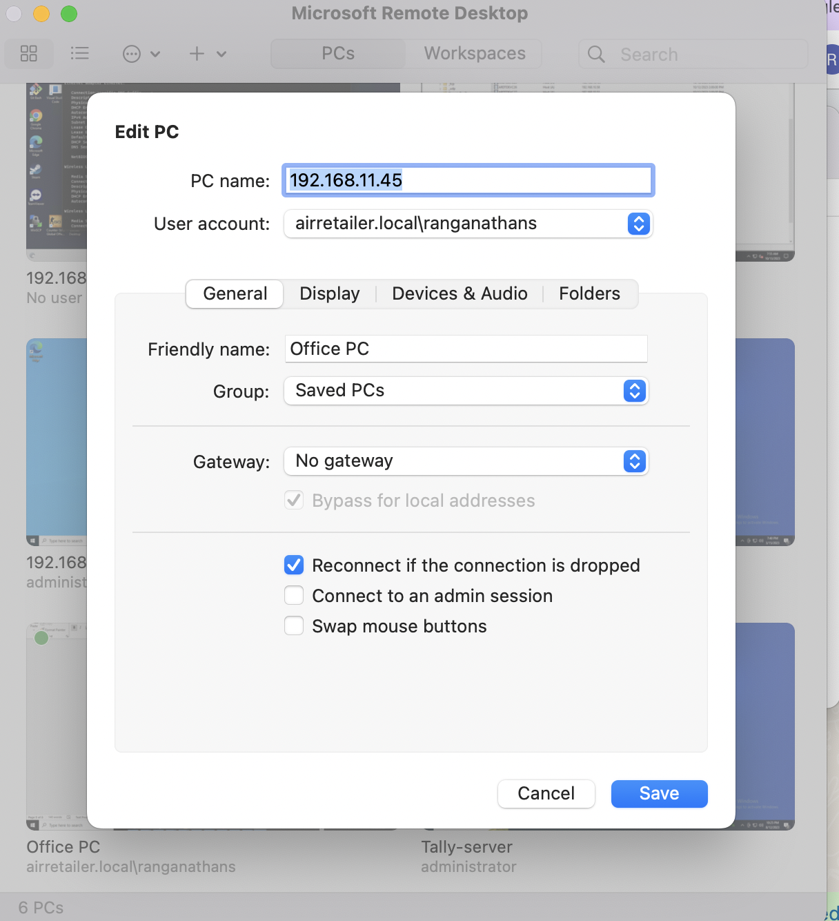
Username: Username@airretailer.local or airretailer.local\username(ex.ranganathans)
Ex: Ranganathan@airretailer.local
Password: Your system password

